



|  |
| --- |
| AN INTRODUCTION TO  THE FUTURE OF WORK  IN THE BLACK RURAL SOUTH |

Harin Contractor  
Spencer Overton

June 2019

**Table of Contents**

Executive Summary 2

Introduction 3

Defining the Black Rural South 3

The History of Work the Black Rural South 8

**Enslaved Persons Farming Cotton Enabled Early U.S. Economic Power**

**Black Education and the Skills vs. Liberal Arts Debate**

**Automating Cotton Farming and the Decline of the Black Rural South**

**The Present Status of Work in the Black Rural South**

**The Opportunity to Increase Prosperity**

**The Opportunity to Increase Racial Equity**

**Labor Markets and Automation in the Black Rural South**

**Recommendations for the Future of Work in the Black Rural South**

**A Black Belt Commission**

**10/20/30**

**Broadband**

**Education, Skills & Entrepreneurship**

**HBCUs as a Platform**

**Transportation**

**A Strong National Workforce System**

Acknowledgments 19

# Executive Summary

(Placeholder)

# Introduction

Media coverage and current future of work discussions organized by big tech, traditional industries, think tanks, and federal policymakers have largely ignored the Black Rural South. While future of work conversations often humanize the issue by invoking “Rust Belt” factory workers and Appalachian coal miners, they generally give little attention to residents of the Black Rural South.

Before the rise of the Industrial Midwest or Coal Country, however, the Black Rural South was the center of the nation’s economy. The cotton gin—an innovation developed just five years after the ratification of the U.S. Constitution—increased the demand for cheap labor to grow raw cotton and accelerated the growth of slavery throughout the Black Rural South. For the first six decades of the 1800s, cotton mostly produced by enslaved labor in the Black Rural South represented over half of American exports, and facilitated the development of several industries in other regions of the United States—textile factories, cotton brokers, ports, shipping lines, banks, and insurance companies.

As a result of cheap labor from enslaved workers, cotton evolved into the “first mass consumer commodity” and the U.S. quickly became the world’s second economic superpower. By the 1860s, the South was producing 75 percent of the world’s cotton, and the lower Mississippi Valley was home to more millionaires than anywhere else in the United States. The Black Rural South laid the foundation for our modern industrial world, and subsequent generations of American leadership in manufacturing, service, and information technology industries.

While the Emancipation Proclamation and the 13th Amendment freed enslaved people in the 1860s, our nation failed to create bridges for most formerly enslaved people and their descendants to transition into better work. One of the more successful attempts—the establishment of “free colored schools” (today’s HBCUs)—provided the origins of a debate between emphasizing skills or higher education that continues today. Unfortunately, the nation prematurely retreated from Reconstruction, and allowed a repressive Jim Crow caste system to evolve that maintained a cheap supply of Black labor for Southern cotton plantation owners.

Eventually, this labor was replaced with automated cotton planting, weeding, and harvesting machines between the 1940s and 1960s, which prompted the second wave of the Great Migration. The federal government promoted automation to keep American cotton competitive internationally (cotton had been the leading American export from 1803 to 1937), but did not provide retraining or relocation assistance for workers who remained in the Black Rural South. As a result, today the Black Rural South has some of the deepest pockets of poverty and preventable disease, and the nation continues to fail to invest adequately in basic infrastructure and services in the region (e.g., water, broadband, transportation, education).

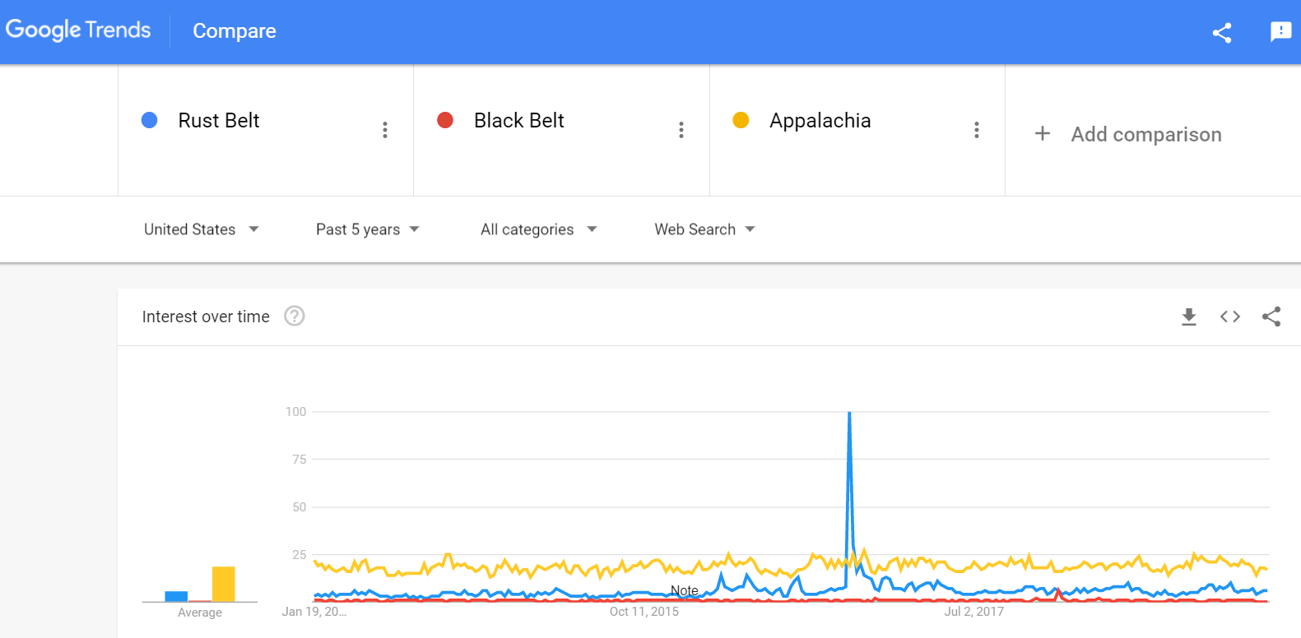

Figure 2: Google Trends of commonly used search terms for economically distressed regions in the U.S. (February 2014 – February 2019)

Any future of work discussion that excludes the Black Rural South is incomplete. We cannot build a modern system that fully transitions American workers to a new economy without consciously addressing the past, present, and future of the Black Rural South. Continued neglect of the residents of the Black Rural South sets the stage to neglect the residents of other regions with industries of declining significance—such as the Industrial Midwest, Appalachia, and eventually Silicon Valley.

This report introduces the Black Rural South to contemporary discussions about the future of work. Part I defines the Black Rural South. Part II reviews the historical and current economy of the Black Rural South. Part III applies a future of work analysis to the Black Rural South, and reveals that 45.5 percent of current occupation activities in the region can be automated with current technologies.[1] Part IV examines structural barriers that hinder a brighter future for residents of the Black Rural South—including a lack of access to broadband and other infrastructure, transportation, and quality education—and the implications of these structural barriers. Part V provides initial recommendations for federal policymakers and private industry.

**Defining the Black Rural South**

Various definitions exist of the “Black Belt” in the American South.[2] In his autobiography *Up From Slavery,* Booker T Washington explains the term was first used to describe a region with rich, dark soil, that enslaved people were taken to this area because it was most profitable for agriculture, and that eventually the term was used to describe the large numbers of African Americans in the area.[3] In 1936, social scientist Arthur Raper described the region as follows:

In the heart of the South there are approximately two hundred counties in which over half the population is Negro. These counties lie in a crescent from Virginia to Texas and constitute the ‘Black Belt.’ They contain the big plantation area of today and coincide with the location of the slave plantains of a few decades ago. . . The Black Belt includes the most fertile soil of the South, and contains a disproportionate number of its poorest people. The ownership of the best land is in the hands of a comparatively small group of white families; landlessness and chronic dependence is the lot of over half the white families and nearly nine-tenths of the colored.[4]

Over the years, researchers have defined the Black Belt using various formulations, including Southern counties with populations that are at least 40 percent Black and rural (147 rural counties),[5] at least one-third Black (42 metro counties and 198 rural counties), [6] and at least 12 percent Black (623 metro and rural counties).[7]

Our report defines the “Black Rural South” as a county that both: 1) has been designated as “rural” by the U.S. Department of Agriculture; and 2) has a population that is at least 35 percent African American. (By comparison, African Americans account for just over 12 percent of the U.S. population and 8 percent of the U.S. rural population). [8] Under our definition, the Black Rural South consists of 156 counties in ten states (Alabama, Arkansas, Florida, Georgia, Louisiana, Mississippi, North Carolina, South Carolina, Tennessee, and Virginia).

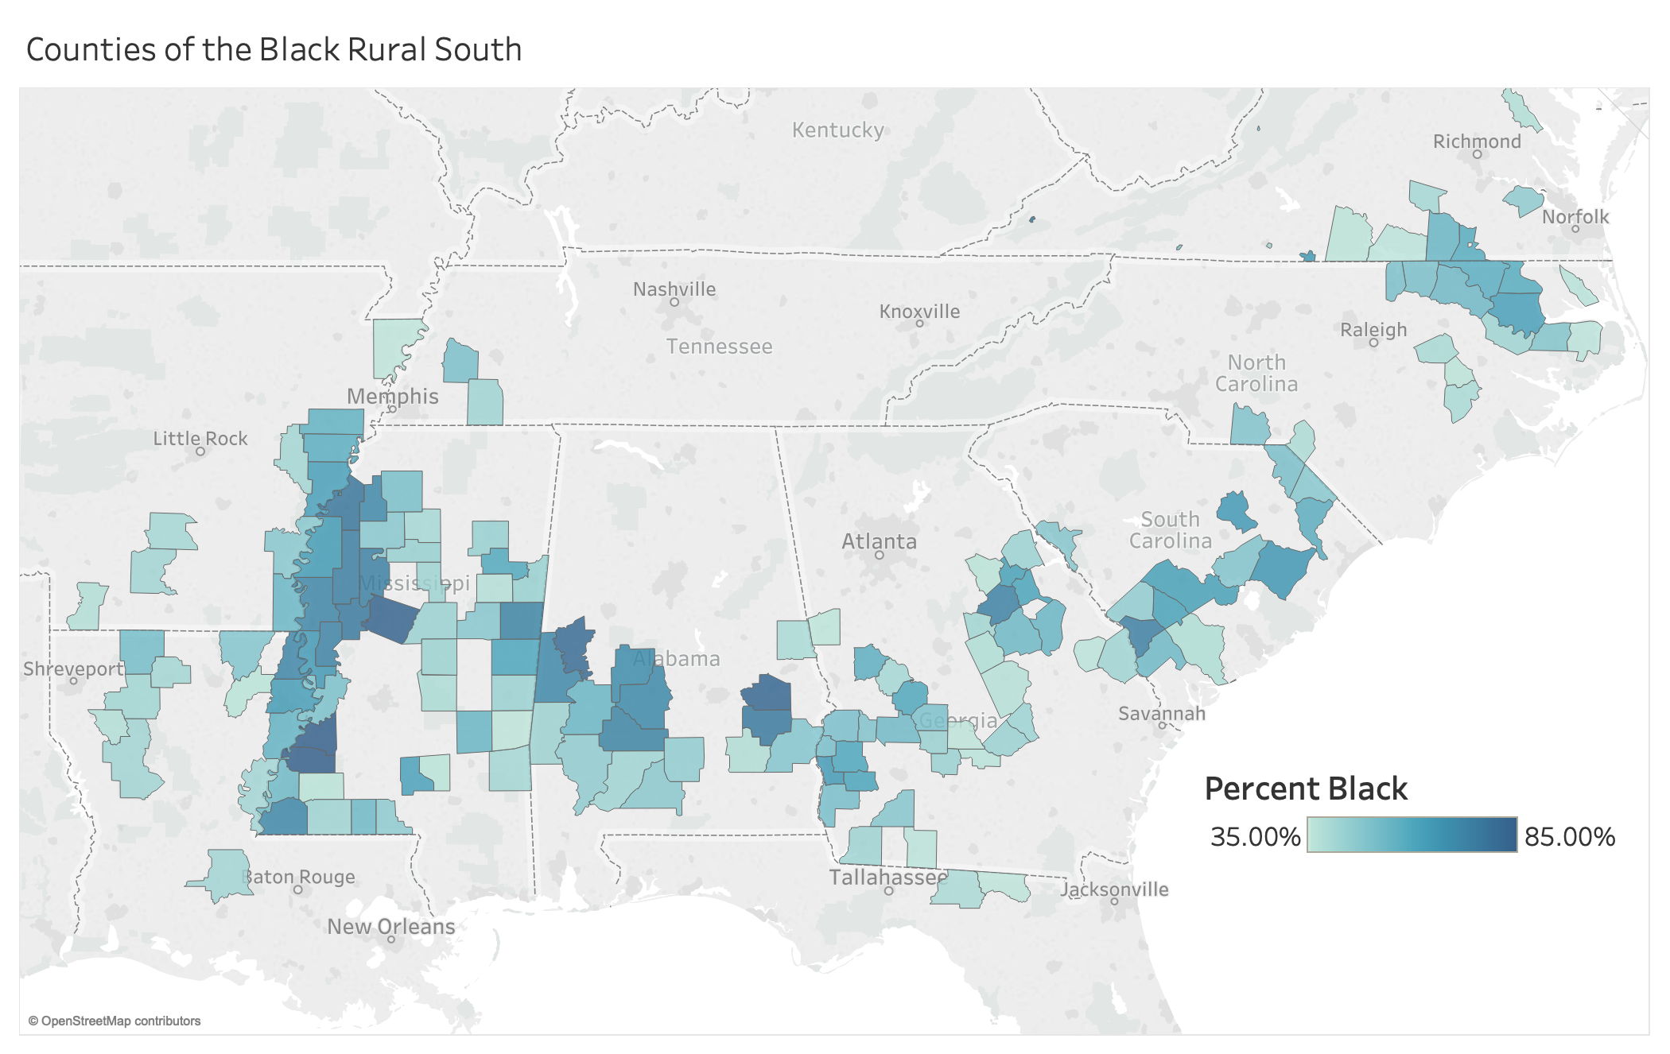

Figure 1: 156 Counties of the Black Rural South

The focus of our report overlaps with, but differs from, the “Black Belt,” as we exclude metropolitan counties in the region. Our definition of Black Rural South is underinclusive, as large concentrations of rural African Americans live in parts of counties that do not meet our 35 percent Black threshold. Recognizing that many datasets are organized by county, we aimed to isolate counties that were clearly part of the Black Rural South to understand the region’s distinctive characteristics relative to other parts of the nation. Thus, this report’s recommendations are applicable to many Black rural communities outside of the 156 counties we define as the Black Rural South.

Demographically, the Black Rural South is very different from other parts of the nation. Approximately 3.6 million residents live in the Black Rural South, and African Americans—who collectively make up 48.3 percent of the population of the region—narrowly edge out Whites as the largest racial group.[9] This is four times higher than the Black percentage of the population in the United States as a whole, and six times higher than the Black percentage of the population in 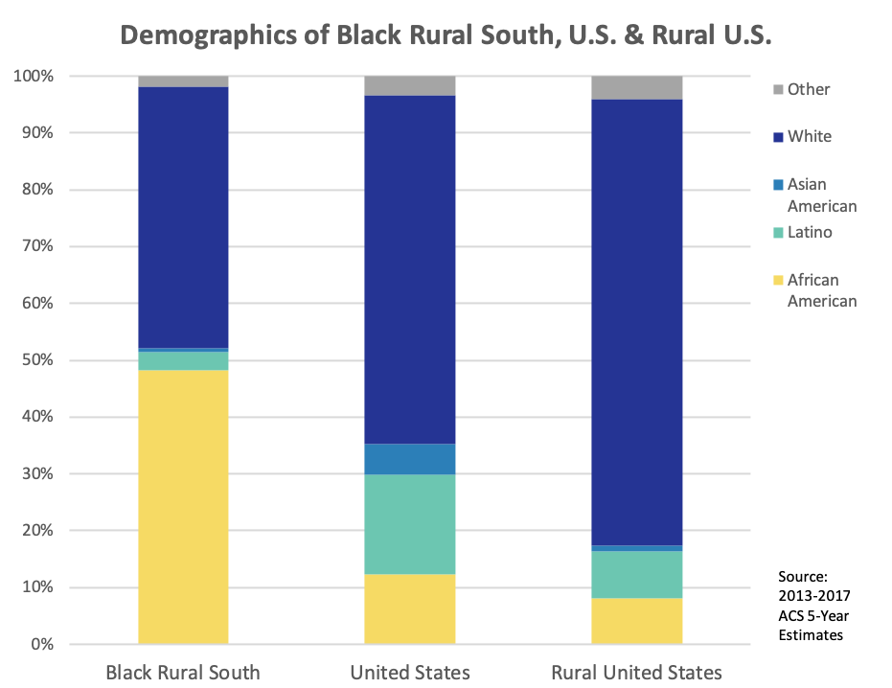all rural counties nationwide.

Figure 2: Demographic breakdown of counties in the Black Rural South, counties in the Rural United States, and counties in the United States.[10]

The Black Rural South is also very Black and White—Latinos, Asian Americans, and other people of color collectively make up only 6 percent of the Black Rural South, compared to 26 percent of the U.S. population as a whole.

**The History of Work in the Black Rural South**

The new technology of the cotton gin in 1793 and the compelled labor of enslaved persons to produce cotton in the Black Rural South allowed the United States to quickly become a global economic superpower. After the Civil War and the end of slavery, efforts to educate Black workers and children resulted in a network of Historically Black Colleges and Universities and a debate over whether to emphasize skills training or classical liberal arts education that continues to shape our thinking today. Many formerly enslaved people and their descendants continued to farm cotton as sharecroppers, only to be displaced by the automation of cotton planting, weeding, and harvesting between the 1940s and 1960s.

### **Enslaved Persons Farming Cotton Enabled Early U.S. Economic Power**

Innovation and the forced unpaid labor of slavery in the Black Rural South provided the foundation of a strong American economy. In 1793, five years after the ratification of the U.S. Constitution, Eli Whitney invented the cotton gin, a machine that could pick seeds out of raw cotton ten times faster than an enslaved person.[11] Initially, many believed the cotton gin would reduce the need for slaves. The increased processing capacity, however, accelerated demand for cotton and for more slaves to grow the crop. The number of slaves quadrupled between 1805 and 1860, and just before the Civil War four of ten people in the 11 states that formed the Confederacy were slaves.[12]

While the largest percentage of enslaved Americans prior to the American Revolution were working on tobacco plantations in Virginia and Maryland, the cotton gin shifted the center of the slave economy to the deep South, and slavery rapidly expanded in Georgia, Alabama, Mississippi, and Louisiana.[13] By 1850, over 70 percent of enslaved persons working in agriculture in the U.S. were “working on cotton plantations.”[14] While the vast majority of these were field hands, some worked in other capacities on plantations (e.g., butlers, waiters, maids, seamstresses, launderers, carriage drivers, stable boys, carpenters, stonemasons, blacksmiths, millers, spinners, and weavers).[15] Only about ten percent of enslaved Africans worked in urban areas.[16]

Production of cotton exploded, and for the first six decades of the 1800s raw cotton comprised more than half of all U.S. exports, “almost all of it grown by slaves.”[17] “[B]y 1850, 72 percent of the cotton consumed in Britain was grown in the United States, with similar proportions for other European countries.”[18] “English textile mills accounted for 40 percent of Britain’s exports,” and one-fifth of Britain’s population were “directly or indirectly involved with cotton textiles.”[19] By the beginning of the U.S. Civil War, the American South “was producing 75 percent of the world’s cotton.”[20] Slavery, and the sharecropping system that replaced slavery in the Black Rural South, made cotton the leading American export from 1803 to 1937.[21]

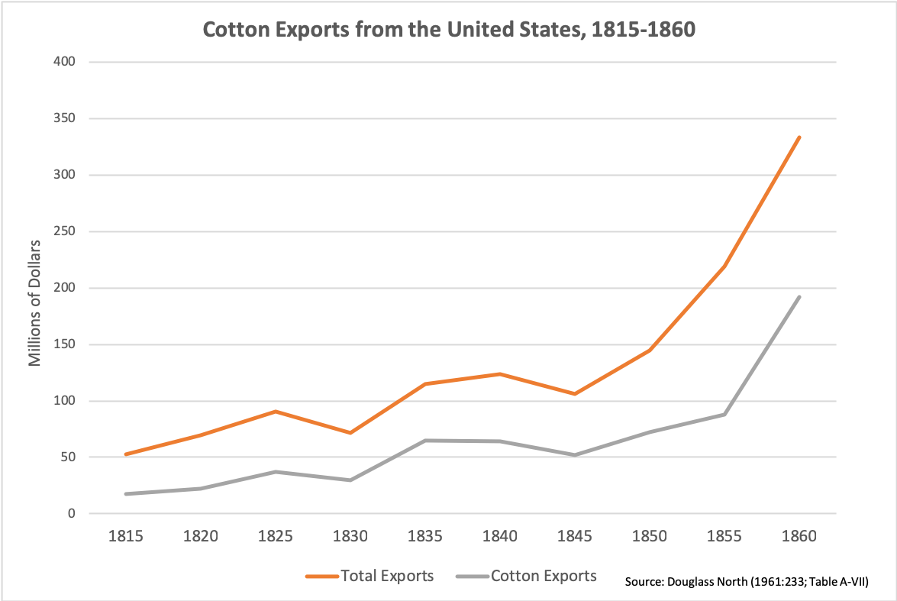[22]

Enslaved people did not just produce the nation’s largest export, but by 1860, the nation’s four million slaves were the second largest asset in the U.S. economy (only behind land).[23] Enslaved people were conservatively worth three times the amount of capital invested in manufacturing, three times the amount invested in railroads, “seven times the amount invested in banks,” and “about seven times the total value of all currency in circulation in the country.”[24] The high value of enslaved persons allowed their owners to use their bodies as collateral to obtain credit from American and English banks so they could buy more tools, land, enslaved persons, and other resources to quickly scale their slavery operations and move into other businesses.

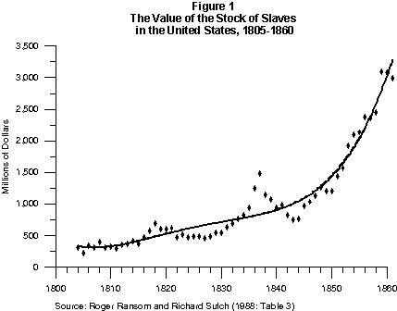

Not unlike today’s Silicon Valley, the Rural Black South became home to concentrated wealth. “[B]y 1860, there were more millionaires living in the lower Mississippi Valley than anywhere else in the United States.”[25]

The Black Rural South generated significant wealth not just in the South, but throughout the United States. Relatively inexpensive cotton resulted in rapid growth of American textile mills—particularly in New England.[26] The banking industry in New York grew as it provided textile mills and plantation owners credit to expand their operations.[27] Insurance companies grew to insure these assets. Cotton brokers in New York emerged to trade cotton in global markets. Shipping lines expanded to export raw cotton and textiles from New York to other nations.[28] The urbanization facilitated by these industries created a demand for food grown in the Midwest. Innovations other than the cotton gin developed by these other industries—such as larger cargo ships powered by steam engines, new financial instruments, looms, and weaving machines—drove the demand for cotton and slave labor.[29]

The modernization of the United States and its prominent role in the global economy were driven in large part by the raw cotton grown by forced labor in the Black Rural South. As Harvard professor Sven Beckert explains, “slavery was just as present in the counting houses of Lower Manhattan, the spinning mills of New England, and the workshops of budding manufacturers in the Blackstone Valley in Massachusetts and Rhode Island as on the plantations in the Yazoo-Mississippi Delta. The slave economy of the Southern states had ripple effects throughout the entire economy, not just shaping but dominating it.”[30]

The economic prominence of the United States and our modern globally-interconnected economy originates in the Black Rural South. Cotton was the “first mass consumer commodity,”[31] and slave plantations were America’s “first ‘big business.’”[32] The Black Rural South allowed the United States to quickly grow to become, along with Great Britain, one of the two first-rank economic powers in the 1800s.[33] In the words of Professor Sven Beckert:

Just as cotton, and with it slavery, became key to the U.S. economy, it also moved to the center of the world economy and its most consequential transformations: the creation of a globally interconnected economy, the Industrial Revolution, the rapid spread of capitalist social relations in many parts of the world, and the Great Divergence—the moment when a few parts of the world became quite suddenly much richer than every other part. The humble fiber, transformed into yarn and cloth, stood at the center of the emergence of the industrial capitalism that is so familiar to us today. Our modern world originates in the cotton factories, cotton ports, and cotton plantations of the 18th and 19th centuries. . . . . It was those connections, over often vast distances, that created an empire of cotton—and with it modern capitalism. . . . We cannot know if the cotton industry was the only possible way into the modern industrial world, but we do know that it was the path to global capitalism. . . . In the first 300 years of the expansion of capitalism, particularly the moment after 1780 when it entered into its decisive industrial phase, it was not the small farmers of the rough New England countryside who established the United States’ economic position. It was the backbreaking labor of unremunerated American slaves in places like South Carolina, Mississippi, and Alabama.[34]

**Black Education and the Skills vs. Liberal Arts Debate**

In the 1860s the Emancipation Proclamation and the 13th Amendment to the U.S. Constitution freed 4 million enslaved people, and a primary issue was transitioning them to a paid labor market.[35] Formerly enslaved people had been prohibited from learning to read and write, and formal education and the acquisition of skills were priorities.

In 1865, Congress created the Bureau of Refugees, Freedmen, and Abandoned Lands (the “Freedmen’s Bureau”), to set up education programs, allocate abandoned land, and take other steps to reconstruct the South.[36] With the support of the Freedmen’s Bureau and religious groups like the American Missionary Association,[37] several “free colored schools” were established.[38] Many of these schools focused initially on primary and secondary learning, and eventually evolved into teacher-training institutions and colleges (which we now refer to as Historically Black Colleges and Universities—or “HBCUs”).[39] For example, the institution that is now Fayetteville State University initially taught primary and intermediate level grades in 1866, and became the first state-sponsored African American teacher training institution in the South in 1877.[40] An additional 16 HBCUs were established due to the federal Agricultural College Act of 1890,[41] such as the South Carolina State Agriculture and Mechanical Institute (which is now South Carolina State University).[42]

While African Americans engaged in public life during the 12 years of Reconstruction following the Civil War,[43] White Southern planters, businessmen, and politicians took advantage of the retreat of federal troops from the South in the late 1870s and used racial violence to discourage Black voting. White Southern interests took control of state legislatures and erected Jim Crow laws to segregate races later upheld by the U.S. Supreme Court in *Plessy v. Ferguson*. They also erected Black Codes that criminalized petty offenses such as being unemployed, which kept Black people tied to plantations and allowed those arrested to be leased to private companies and returned to forced labor.[44]

Within this context, different visions of Black educational institutions emerged—one emphasizing the acquisition of practical skills, and the other emphasizing a classical liberal arts education. In 1866 the “Fisk Free Colored School” (today known as Fisk University) was opened in Nashville as a liberal arts school, with the belief that African Americans “needed to be educated in the social sciences in order to lead.”[45] In contrast, believing that skills and trades provided the formerly enslaved the fastest road to resources and self-sufficiency, Union veteran General Samuel Armstrong founded the Hampton Normal and Agricultural Institute in Virginia in 1868 (today known as Hampton University).[46]

Booker T. Washington, a graduate of Hampton who in 1881 became the first principal of Tuskegee Normal School for Colored Teachers in Alabama (now Tuskegee University),[47] became the most prominent spokesperson for skills development. Washington focused on basic education and skills in agriculture, industry, and domestic service because he believed those who “contribute to the markets of the world” would be valued.[48] Dr. W.E.B. DuBois, a Fisk graduate who returned to teach at the institution after earning a PhD at Harvard, became a leading critic. Du Bois believed that Washington was too accommodating to Whites, and pushed voting rights, civic equality with Whites, and higher liberal arts education of African Americans.[49]

While appearing to be accommodating, Washington was both engaged in politics and committed to education. Washington secretly invested money into legal challenges to Jim Crow laws, quietly enlisted the aid of W.E.B. DuBois to fight railroad segregation in Tennessee, and worked behind the scenes to secure the appointment of federal officials sympathetic to African Americans.[50] Washington and businessman Julius Rosenwald also developed a matching grant program that facilitated the construction of almost 5,000 schoolhouses between 1913 and 1931, which educated about a third of southern rural black children. Within twenty years, the “Rosenwald Schools” reduced the Black-White education gap in Southern states from about 3.5 years to 0.5 years.[51]

**Automating Cotton Farming and the Decline of the Black Rural South**

While the invention of the cotton gin in the late 1790s led to the rapid expansion of slavery and the economic rise of white plantation owners in the Black Rural South, the development and gradual adoption of mechanical cotton farming machinery between the 1940s and 1960s deepened poverty in a region that had previously relied on cheap labor.

Despite efforts to promote education and skills, many former enslaved persons and their descendants continued to work on cotton plantations as sharecroppers, tenants, and some owners.[52] The Civil War transitioned cotton production from slavery to sharecropping, but it did not change the primary technology to grow cotton—a plow, a team of mules, a wagon, and hand tools. By 1929, three out of four Black farmers (owners, tenants, and sharecroppers) received at least 40 percent of their gross income from cotton. In addition, Negro wage labor working for White farmers produced an unknown—but probably considerable—amount of cotton.[53] Repressive Jim Crow laws and an abundance of formerly enslaved Black communities made labor cheap, and thus Southern planters did not need to automate cotton production.[54]

The first patent for a mechanical cotton picker was issued in 1850,[55] but the technology was not sufficiently developed and commercially viable until the 1940s. While only six percent of U.S. cotton was harvested mechanically in 1949, that number jumped to 96 percent by 1969, and the percentage of hand-picked cotton declined accordingly.[56]

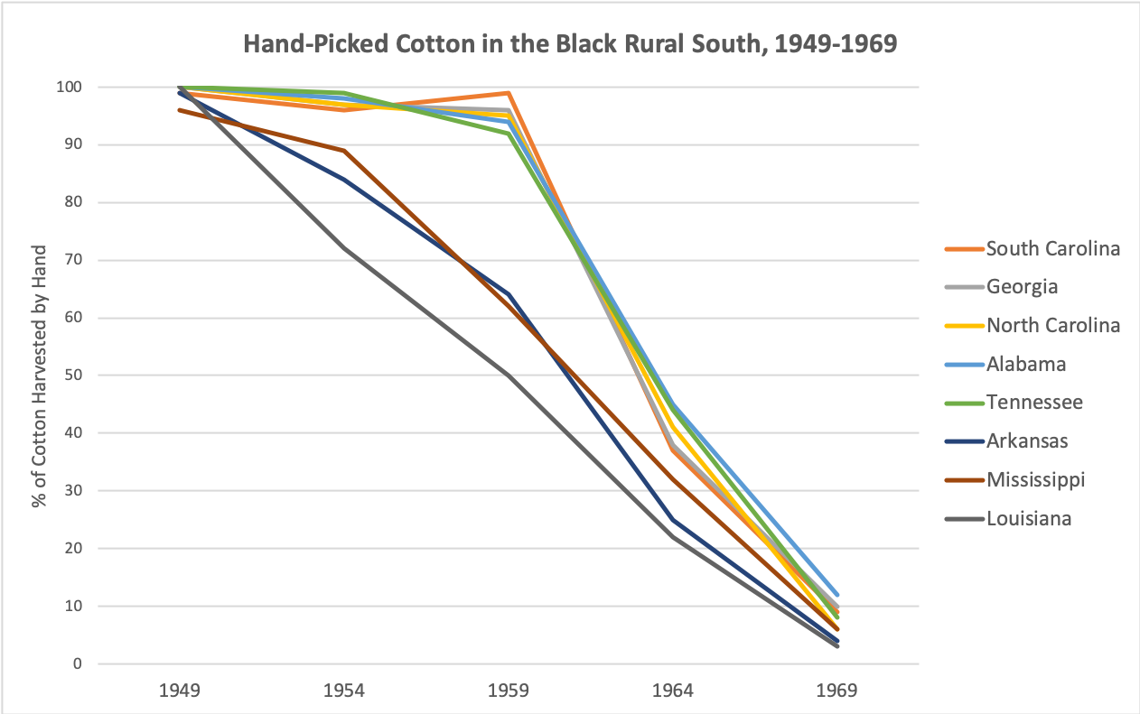

As Professor Donald Holley wrote:

While the cotton gin was the invention that created the Old South, the modern South is the product of the mechanical cotton picker. A century and a half after Whitney, the South experienced another major technological innovation that created revolutionary change. The cotton picker, which went into commercial production after World War II, generated great fear and trepidation. The cotton gin had set off a series of events that produced the antebellum South, bolstered slavery, and contributed to the Civil War. The potential effect of the mechanical cotton picker was seen as equally prodigious. This new machine symbolized a revolution that would eliminate hand labor from the cotton harvest and free the region from its dependence on labor-intensive agriculture. The effect on the region’s sharecroppers was implicitly disastrous. Since many croppers were black, this outcome seemed especially fearful. At the same time, cotton was the last major crop to achieve full mechanization, enabling cotton farmers to work more efficiently and earning them greater prosperity.[57]

Experts differ on which technological driver was more significant in reducing the hand picking of cotton—the lower cost of machine harvesting that displaced farm workers (decline in labor demand), or increased wages in manufacturing that drew farm workers away from the South (decline in labor supply). Decline in labor demand estimates range from 21 percent of the decrease in handpicking (1986),[58] to just under 40 percent (2000),[59] to a majority (2003).[60]

Before extensive roll out of automated cotton farming, industry leaders argued that a decline in labor supply would be the driver of automation, and cautioned against panic by workers. In 1947 in an address entitled “The Cotton Industry’s Responsibility in Mechanization,” the president of the National Cotton Council claimed that mechanization would not push workers off of farms, but instead replace workers who had left the South.[61] Economists predicted that mechanization would be rolled in gradually, and that at maximum of 518,000 workers would be displaced by picking machines.[62]

Granted, factors other than the automation of cotton farming contributed to the deepening of poverty of the Black Rural South, including the invasion of the boll weevil beetle that reduced crop yields in infested areas by 50 percent, a failure to diversify economically, soil erosion, repressive Jim Crow laws,[63] competition from international cotton and synthetic fabrics, and the decline of cotton prices.[64] However, the automation of cotton—combined with higher-paying manufacturing opportunities outside of the South—were key factors.[65]

In many ways, the automation of cotton farming helped many Black Southerners. Automation of cotton farming prompted many to look for higher quality work that was less backstraining and less monotonous.[66] Mechanization of cotton also coincided with the American Civil Rights Movement, and reduced incentives for White Southerners to defend Jim Crow to maintain a cheap Black labor force.[67]

Automation of cotton growing also motivated many Black workers to leave the South for better lives with higher incomes and less overt discrimination. A county’s share of land planted in cotton predicted Black outmigration in the 1940s and 1960s, as the mechanical cotton planter and weeder were initially phased in, and later the mechanical cotton harvester.[68] From 1940 to 1970, nearly 4 million African Americans left the South in the second wave of the Great Migration.[69] While more than 90 percent of African Americans lived in the South in 1910, by 1970 most African Americans lived outside of the South.[70] Black men settling in the North earned at least 100 more than those who stayed in the South.[71] The children of Black families who left the South enjoyed high school graduation rates 11 percent higher than those who stayed in the South, “made $1000 more per year in 2017 dollars, and were 11 percent less likely to be in poverty”—even after controlling for education, occupation, and income of parents.[72]

Unfortunately, for those workers who were displaced and remained in the Black Rural South, the federal government did not enact programs for “retraining or relocation assistance for displaced farm workers” as it does for workers experiencing trade-related job loss.[73] Retraining and relocation assistance was unavailable, even though the federal government “heavily subsidized and coordinated the mechanization of cotton production” to keep American cotton competitive in international markets.[74] The federal government, cotton plantation owners, and farm machinery companies effectively externalized the costs of automation on to those least positioned to bear it—Black workers whose ancestors were enslaved people forced to grow the cotton that made a young America the world’s second economic superpower.[75] The negative shift in labor demand from automation in an industry that had previously depended on a cheap labor supply drove even deeper poverty in the Black Rural South.[76]

**The Present Status of Work in the Black Rural South**

The Black Rural South, a product of the 1700s and 1800s, remains discernable today.[77] A century and a half after Emancipation, generations of attracting businesses interested in a large supply of low-wage, low-skill workers with few other options has had short-term benefits, but long-term costs. Unemployment, labor force participation, earnings, and childhood poverty are far worse in the Black Rural South than in other parts of the United States. Stark racial disparities persist.

The data on the Black Rural South provide sobering insights into the future of work in the rest of the United States. The costs of failing to develop systems for sustained *and inclusive* investment in human capital (e.g., education, skills, infrastructure) are high. The data also suggest that in developing strategies for a bright future of work in the United States, the Black Rural South presents significant opportunities for growth.

**The Opportunity to Increase Prosperity**

The federal government and American companies have a significant opportunity to increase prosperity in the Black Rural South. Generally, unemployment, labor force participation, income, and child poverty rates are worse in the region than in other parts of the United States.

For example, the Black Rural South has produced high unemployment rates for decades. While all other regions cluster at or near 6 percent, the Black Rural South’s rate is generally 2 percentage points higher. The Black Rural South’s unemployment rate is also more volatile than the rate in other regions. From 2000 to 2010, the recession caused the unemployment rate in the Black Rural South to jump over 7 percentage points, compared to only 4 percentage points in non-southern rural counties. [[NOTE FROM AMY: REWEIGHT BY LABOR FORCE INSTEAD OF POPULATION]]

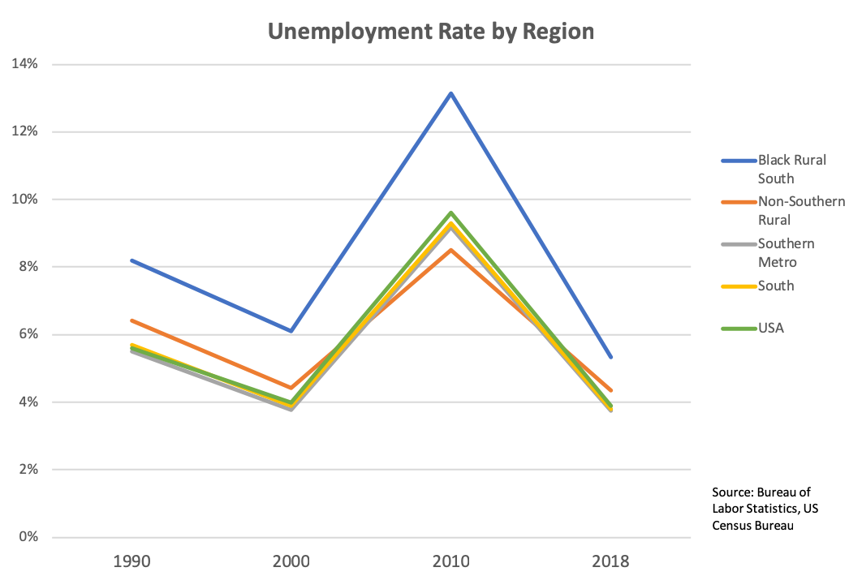

Figure 2: Average Non-Seasonally Adjusted Unemployment Rate in 1990, 2000, 2010, and 2018, weighted by 1990, 2000, 2010 Census Bureau Population and 2013-2017 ACS Population estimates respectively, of counties in the Black Rural South, Rural counties not in the South, Metro counties in the South, Southern counties, and the entire USA. This figure is **not** broken down by race.

A large portion of the Black Rural South’s population, both Black and White, is outside of the labor force altogether. The region’s labor force participation rate is 51.8 percent, and is 8.1 points lower than in rural counties outside the South and 11.6 points lower than the United States as a whole.

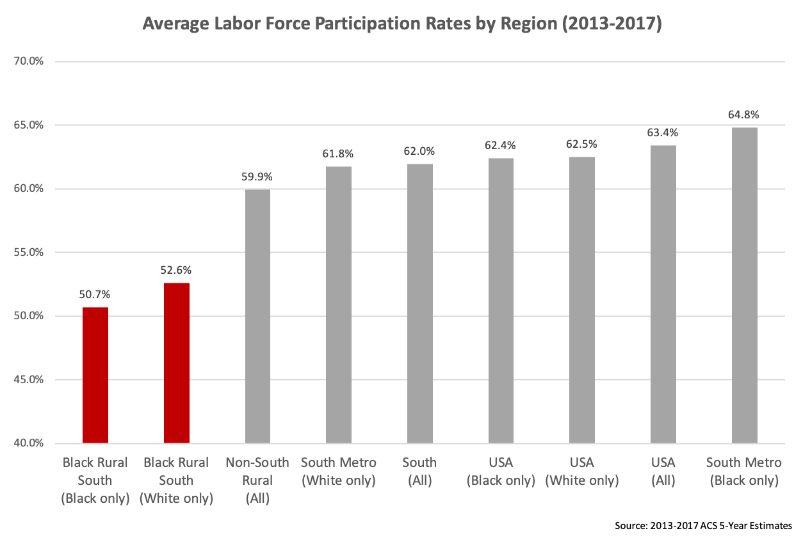

Figure 4: Average Labor Force Participation Rate over 2013-2017 of counties in the Black Rural South, Rural counties not in the South, Metro counties in the South, Southern counties, and the entire USA, for the whole population and for demographic categories ‘Black or African American Alone’ and ‘White Alone, Not Hispanic or Latino’.

Similarly, while the household incomes of other regions have largely clustered together, the household income in the Black Rural South has lagged behind other regions, and the growth rate of those incomes seems to be slowing over the past two decades.

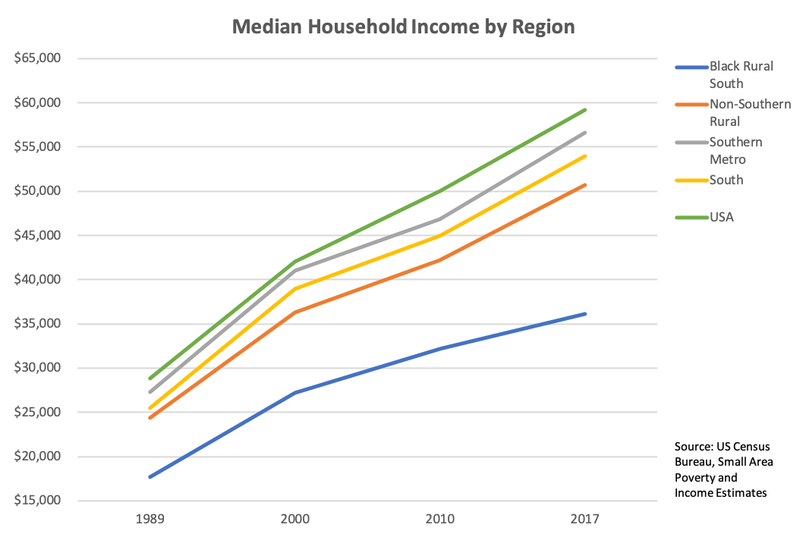

Figure 7: Median Household Income in 1989, 2000, 2010, and 2017, weighted by 1990, 2000, 2010 Census Bureau Population and 2013-2017 ACS Population estimates respectively, of counties in the Black Rural South, Rural counties not in the South, Metro counties in the South, Southern counties, and the entire USA. This figure is **not** broken down by race, and has **not** been adjusted for inflation.

The future of work in the United States is also shaped, in part, by the percentage of children in poverty. Just like income and unemployment, childhood poverty rates are much worse in the Black Rural South than in other regions, and are about ten points higher than overall poverty.

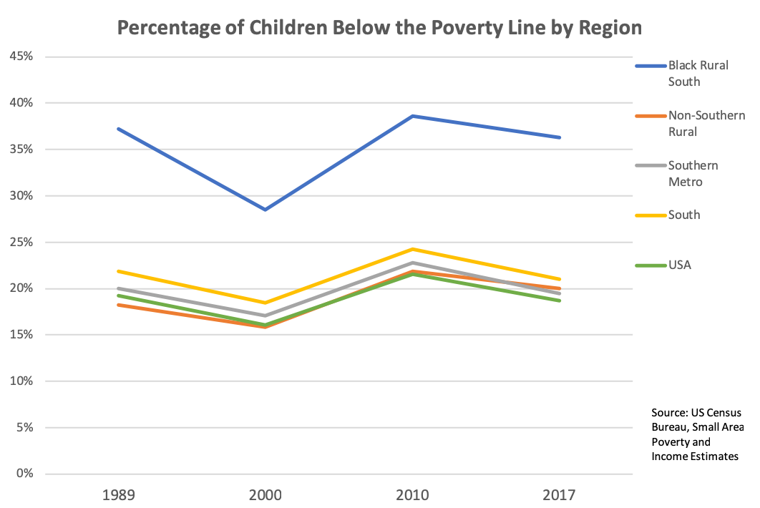

Figure 12: Percentage of Population Under 18 Below the Poverty Line in 1989, 2000, 2010, and 2017, weighted by 1990, 2000, 2010 Census Bureau Population and 2013-2017 ACS Population estimates respectively, of counties in the Black Rural South, Rural counties not in the South, Metro counties in the South, Southern counties, and the entire USA. This figure is **not** broken down by race, and has **not** been adjusted for inflation.

**The Opportunity to Increase Racial Equity**

The federal government and the American companies also have a significant opportunity to increase racial equity in the Black Rural South. On most major economic indicators outside of labor force participation, African Americans fare much worse than Whites.

For example, the unemployment rate among African Americans in the Black Rural South is 14.5 percent, compared to only 5.9 percent for Whites in the region. The White unemployment rate in the Black Rural South is lowerthan the rates of the South and the U.S. as a whole, and comparable to the unemployment rate across rural counties outside of the South.

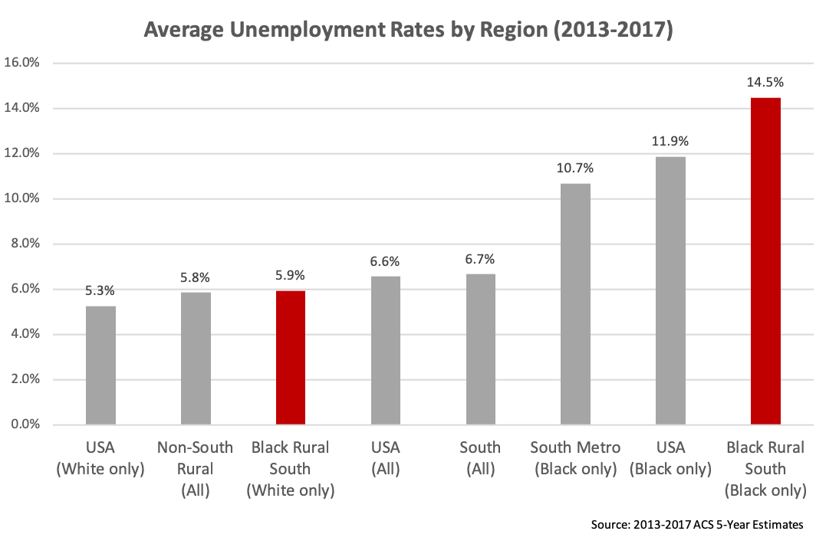

Figure 3: Average Unemployment Rate over 2013-2017, weighted by average labor force over 2013-2017, of counties in the Black Rural South, Rural counties not in the South, Metro counties in the South, Southern counties, and the entire USA, for the whole population and for demographic categories ‘Black or African American Alone’ and ‘White Alone, Not Hispanic or Latino’. Note that the White unemployment rate in the Southern Metro, not included in this figure, is 5.1%, just slightly below the White unemployment rate across the USA.

Earnings data in the Black Rural South reveal similar racial disparities. Whites in the Black Rural South earn about as much as the national average earnings. In contrast, African Americans in the Black Rural South earn about two-thirds the amount of Whites in the Black Rural South, and just over half of the amount of Whites nationwide.

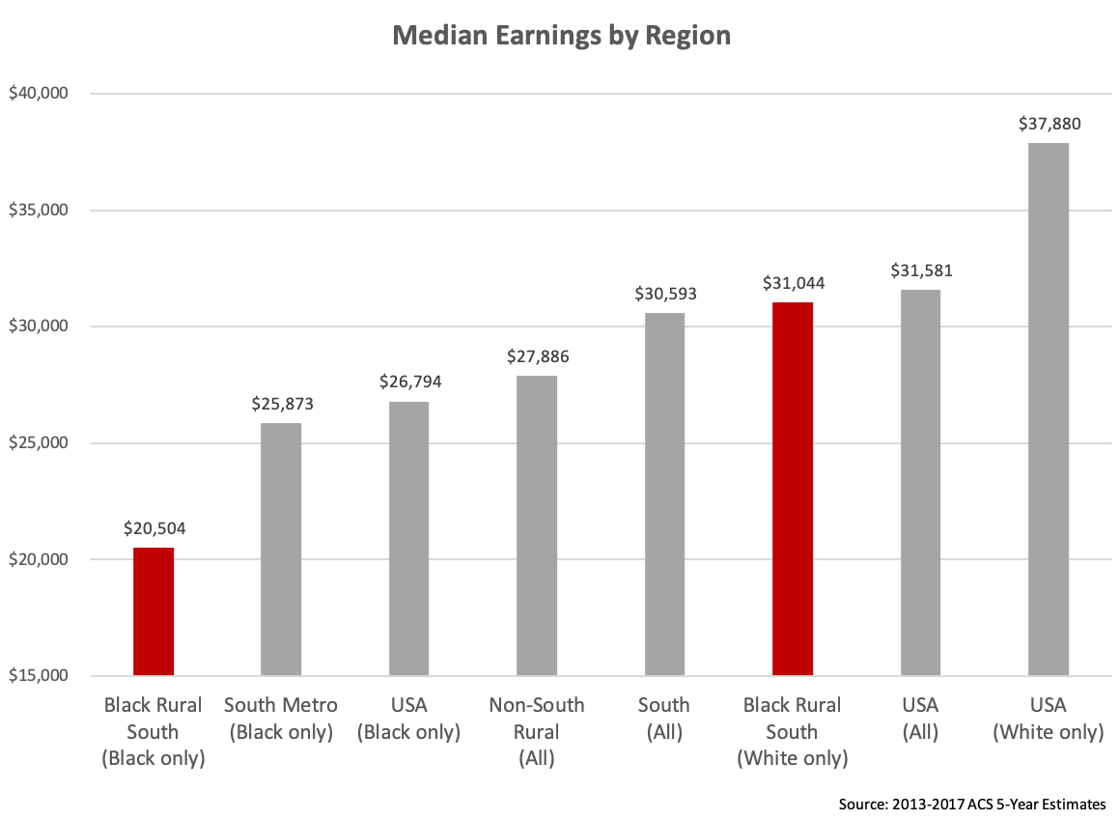

Figure 8: Median Earnings in the Past 12 Months among Population 16 Years and Older with Earnings in the Past 12 Months, Averaged over 2013-2017. Weighted by 2013-2017 ACS 5-Year Population Estimates. Data is for counties in the Black Rural South, Rural counties not in the South, Metro counties in the South, Southern counties, and the entire USA, for the whole population and for demographic categories ‘Black or African American Alone’ and ‘White Alone, Not Hispanic or Latino’. Note that the Median Earnings for Whites in the South Metro, not included in this graph, are $38,576.

The racial disparities in the Black Rural South stem in part from the fact that most Black households are concentrated into lower-income positions, while White households are concentrated into higher-income positions. As evidenced by the graph below, there is relatively relatively little overlap between the two.[78] [AMY & HARIN: Amy, is this a substitute for the quintile graph I was looking for? Is it better to do earnings rather than income, or income rather than earnings? Is it fair to infer from this that Whites are concentrated into higher earning positions, while Black folks are concentrated in lower earning positions? Also, explain this chart to me. I think I understand income, but I don’t clearly understand density. Also is there a way to make the income the vertical lines, so that the White people are visually on top?]

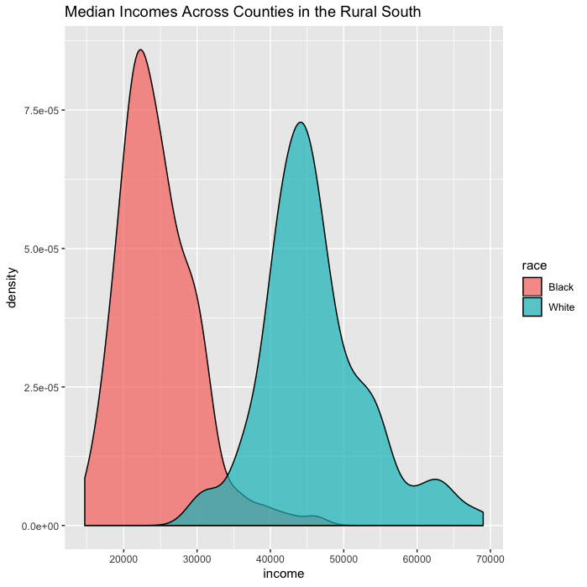

Figure 4: Median Weighted Incomes Across Counties in the Black Rural South

Not surprisingly, the Black Rural South’s racial disparities in unemployment and income are reflected in racial disparities in the percentage of children who live poverty. [AMY & HARIN: Can we convert the chart below to percentage of children in poverty? Thanks]

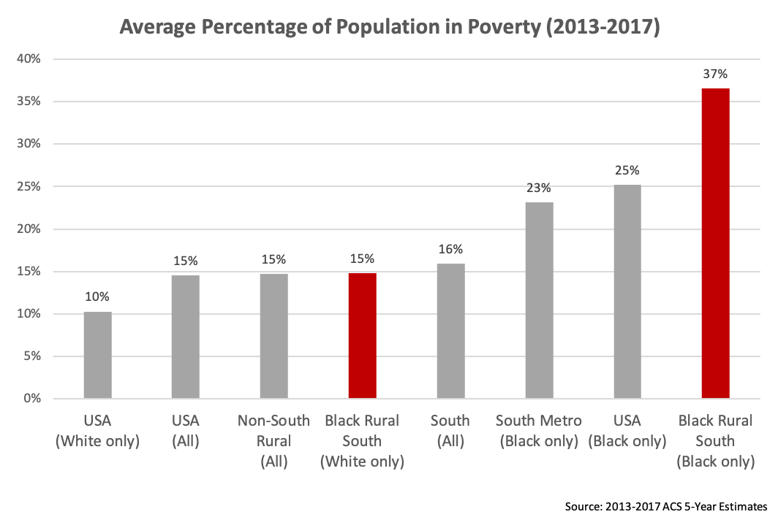

Figure 13: Percentage of Population for which Poverty Status is Determined that is Below the Poverty Line, averaged over 2013-2017. Data is for counties in the Black Rural South, Rural counties not in the South, Metro counties in the South, Southern counties, and the entire USA, for the whole population and for demographic categories ‘Black or African American Alone’ and ‘White Alone, Not Hispanic or Latino’. Note that the Poverty Rate among Whites in the Southern Metro counties, omitted from this graph, is 10%.

The racial inequality in the Black Rural South is illustrated, in part, by the fact that White people in the region have unemployment and poverty rates comparable to those of other rural Whites throughout the United States. Indeed, despite high Black poverty rates in the Black Rural South, Whites living in the Black Rural South have much lower poverty rates than Whites who live in southern rural counties with few African Americans (over 90 percent White, see the chart below). A similar pattern exists for unemployment rates (the unemployment rate for Whites in the Black Rural South is 5.9 percent, compared to 5.2 percent for non-Southern rural Whites and 7.0 percent for Southern rural Whites in counties that are at least 90 percent White). [AMY: Revise the chart below to go from 1% to 20% to visually represent the relative parity of the first three columns. We’ll strike the unemployment chart]

* 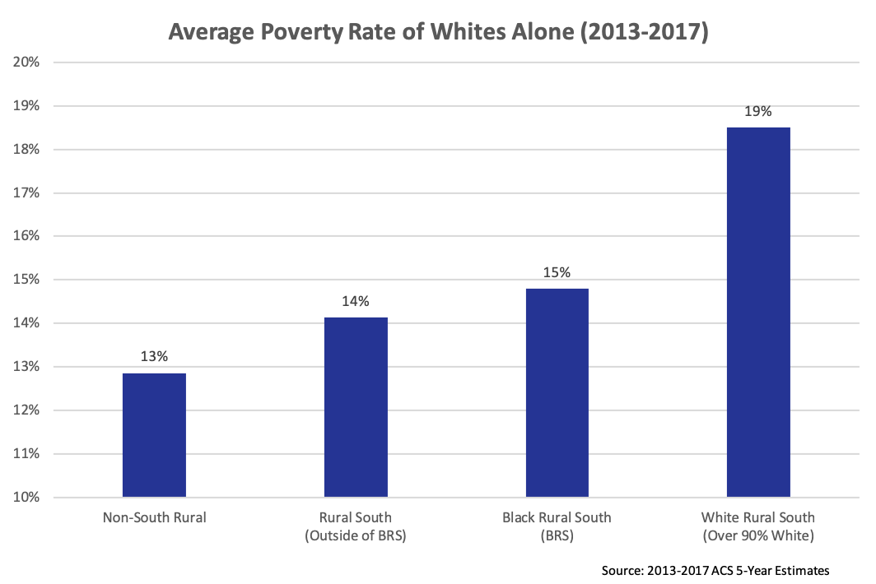

Figure 14: Percentage of Population for which Poverty Status is Determined that is Below the Poverty Line, averaged over 2013-2017, for ‘White Alone, Not Hispanic or Latino’. Data is for counties in the Black Rural South, Rural counties not in the South, Rural counties in the South that are not part of the ‘Black Rural South’, and White Rural South (Rural Counties in the South that are over 90% White).

### 

**Labor Markets and Automation in the Black Rural South**

**Recommendations for the Future of Work in the Black Rural South**

**A Black Belt Commission**

**10/20/30**

**Broadband**

**Education, Skills & Entrepreneurship**

**HBCUs as a Platform**

**Transportation**

**A Strong National Workforce System**

About the Authors

**Harin Contractor** is the Workforce Policy Director of the Joint Center for Political and Economic Studies. Harin worked at a tech start-up that used government data to empower communities. He also started the Data Analytics unit of the Universal Service Administrative Company (USAC), a government-run nonprofit that provides $10 billion of grants to facilitate broadband access across the United States. Harin worked in the Obama Administration at the U.S. Department of Labor as the Economic Policy Advisor to the Secretary. Harin is a graduate of the University of Georgia and the University of Chicago.

**Spencer Overton** is the President of the Joint Center. He is also a tenured Professor of Law at George Washington University, where he teaches and writes on race and the law and election law. Spencer is the co-author of 5G, Smart Cities & Communities of Color and several articles related to the future of work, and he has also presented on innovation and communities of color at various venues, including the African American Mayors Association Annual Conference, Google, LinkedIn, the Multicultural Media Telecom and Internet Council’s (MMTC) Annual Broadband and Social Justice Summit, the National Black Caucus of State Legislators Annual Legislative Conference, and the U.S. House of Representatives. During the 2007-2008 presidential campaign, Spencer chaired Government Reform Policy for then-U.S. Senator Barack Obama, and during the 2008 Obama-­Biden Transition he served as a member of the Technology, Innovation, and Government Reform (TIGER) policy team. In the first term of the Obama Administration, Spencer served as Principal Deputy Assistant Attorney General of the Office of Legal Policy, the “think tank” of the Department of Justice that coordinates policy and regulations within DOJ and with the White House and other agencies. Spencer is an honors graduate of both Hampton University and Harvard Law School, he clerked for U.S. Court of Appeals Judge Damon J. Keith, and he practiced law at Debevoise & Plimpton. Three of his great-grandparents were enslaved people in the American South.

# Acknowledgments

We are appreciative of Google for its financial support of this report, as well as its general support of the Joint Center.

Harin: You know who gave feedback better than I do—please include

Who read entire versions of the report and provided feedback:

Who read sections and provided feedback:

Who provided ideas in the initial stages, and general feedback:

Amy Kim, Fane Wolfer, Jessica Fulton, Victoria Johnson

McKinsey

Opinions expressed in Joint Center publications are those of the authors and do not necessarily reflect the views of the staff, officers, or governors of the Joint Center for Political and Economic Studies or of the organizations that support the Joint Center and its research.

© Copyright 2019

All rights reserved.

Joint Center for Political and Economic Studies

[info@jointcenter.org](mailto:info@jointcenter.org)

[www.jointcenter.org](http://www.jointcenter.org)

@JointCenter



The Joint Center for Political and Economic Studies, founded in 1970, is a 501(c)(3) non-profit organization based in Washington, DC. The Joint Center's mission is to inform and illuminate the nation's major public policy debates through research, analysis, and information dissemination in order to improve the socioeconomic status of Black communities in the United States; expand their effective participation in the political and public policy arenas; and promote communication and relationships across racial and ethnic lines to strengthen the nation's pluralistic society. We tailor our solutions to be accessible and we collaborate with those who have shared interests to maximize impact.

**Media Contact**

[press@jointcenter.org](mailto:press@jointcenter.org)| 202.789.3500 EXT 105

© Copyright 2019

All rights reserved.

**Joint Center for Political and Economic Studies**

633 Pennsylvania Ave., NW

Washington, DC 20004

[info@jointcenter.org](mailto:info@jointcenter.org)

[www.jointcenter.org](http://www.jointcenter.org)

@JointCenter

1. McKinsey Data
2. Gerald R. Webster and Jerrod Bowman, “Quantitatively Delineating the Black Belt Geographic Region,” *Southeastern Geographer* 48, no. 1 (May 2008): 3 (““The basis for the label ‘Black Belt’ has been confused if not disputed for decades. . . . ‘It is still a moot question as to whether the name of the area came from the color of the soil, or because of the heavy Negro population.’”).
3. Booker T. Washington, *Up From Slavery* (New York: Doubleday, 1907), 108.
4. Arthur F. Raper, *Preface to Peasantry: A Tale of Two Black Belt Counties* (Columbia: University of South Carolina Press, 2005), 3.
5. William W. Falk and Thomas A. Lyson, *High Tech, Low Tech, No Tech: Recent Industrial and Occupational Change in the South* (Albany, N.Y.: State University of New York, 1988), 55.
6. Samuel D. Calhoun, Richard J. Reeder and Faqir S. Bagi, “[Federal Funds in the Black Belt](https://web.archive.org/web/20120404222927/https:/www.ers.usda.gov/publications/ruralamerica/ra151/ra151d.pdf),” *Rural America* 15, no. 1 (January 2000): 26. *See also* William W. Falk and Bruce H. Rankin, “[The Cost of Being Black in the Black Belt](https://www.jstor.org/stable/3096964),” *Social Problems* 39, no. 3 (August 1992): 302 (“We operationalize the Black Belt as consisting of all county groups in the nonmetropolitan South with 33 percent or greater black population. . . . “).
7. Joyce E. Allen-Smith, Ronald C. Wimberley, and Libby V. Morris, “[America's Forgotten People and Places: Ending the Legacy of Poverty in the Rural South](http://citeseerx.ist.psu.edu/viewdoc/download?doi=10.1.1.520.6879&rep=rep1&type=pdf),” *Journal of Agricultural and Applied Economics* 32, no. 2 (August 2000): 326 (defining the Black Belt as counties in the 11 “Old South” states that have at least the national percentage of the Black population (at least 12 percent), and finding 623 counties fit this definition)
8. [*Rural America at a Glance: 2018 Edition*](https://www.ers.usda.gov/webdocs/publications/90556/eib-200.pdf?v=5899.2) (Washington, DC: USDA, 2018), 3.
9. U.S. Census Bureau. “[DP05: ACS Demographic and Housing Estimates](https://data.census.gov/cedsci/table?hidePreview=true&table=DP05&tid=ACSDP5Y2017.DP05&lastDisplayedRow=81).” Data Set: American Community Survey 5-Year Estimates, 2013-2017. 
10. Demographic categories, according to ACS: ‘Not Hispanic – Black or African American only’, ‘Hispanic/Latino’, ‘Not Hispanic – Asian only’, ‘Not Hispanic – White only’, and ‘Not Hispanic – Other Race or Two or More Races’.
11. Greg Timmons, “[How Slavery Became the Economic Engine of the South](https://www.history.com/news/slavery-profitable-southern-economy),” *History*, March 6, 2018 (“In 1794, inventor Eli Whitney devised a machine that combed the cotton bolls free of their seeds in very short order. Manually, one slave could pick the seeds out of 10 pounds of cotton in a day. The [cotton gin](https://www.history.com/topics/inventions/cotton-gin-and-eli-whitney) could process 100 pounds in the same time.”)
12. Roger L. Ransom, “[The Economics of the Civil War](https://eh.net/encyclopedia/the-economics-of-the-civil-war/),” *EH.net* (“In 1805 there were just over one million slaves worth about $300 million; fifty-five years later there were four million slaves worth close to $3 billion. In the 11 states that eventually formed the Confederacy, four out of ten people were slaves in 1860…”).
13. Howard Dodson, Jubilee: The Emergence of African-American Culture (Washington, DC: National Geographic, 2003), __ (“The invention of the cotton gin in 1793 gave slavery a new life in the United States. . . This shift of the slave economy from the upper South (Virginia and Maryland) to the lower South was accompanied by a comparable shift of the enslaved African population to the lower South and West.”)
14. Howard Dodson, Jubilee: The Emergence of African-American Culture (Washington, DC: National Geographic, 2003), 57 (“After the abolition of the slave trade in 1808, the principal source of the expansion of slavery into the lower South was the domestic slave trade from the upper South. By 1850, 1.8 million of the 2.5 million enslaved Africans employed in agriculture in the United States were working on cotton plantations.”).
15. Howard Dodson, Jubilee: The Emergence of African-American Culture (Washington, DC: National Geographic, 2003), 57 (“The vast majority of enslaved Africans employed in plantation agriculture were field hands. Even on plantations, however, they worked in other capacities. Some were domestics and worked as butlers, waiters, maids, seamstresses, and launderers. Others were assigned as carriage drivers, hostlers, and stable boys. Artisans—carpenters, stonemasons, blacksmiths, millers, coopers, spinners, and weavers—were also employed as part of plantation labor forces.”).
16. Howard Dodson, Jubilee: The Emergence of African-American Culture (Washington, DC: National Geographic, 2003), 57 (“Enslaved Africans also worked in urban areas. Upward of ten percent of the enslaved African population in the United States lived in cities.”).
17. Sven Beckert, “[Slavery and Capitalism](https://www.chronicle.com/article/SlaveryCapitalism/150787),” *The Chronicle of Higher Education*, December 12, 2014 (“More than half of the nation’s exports in the first six decades of the 19th century consisted of raw cotton, almost all of it grown by slaves.”).
18. Sven Beckert, “[Slavery and Capitalism](https://www.chronicle.com/article/SlaveryCapitalism/150787),” *The Chronicle of Higher Education*, December 12, 2014 (“[B]y 1850, 72 percent of the cotton consumed in Britain was grown in the United States, with similar proportions for other European countries.”)
19. Gene Dattel, “Cotton, the Oil of the Nineteenth Century,” *The International Economy* 24, no. 1 (Winter 2010): __ (“Cotton was the leading American export from 1803 to 1937”).
20. Greg Timmons, “[How Slavery Became the Economic Engine of the South](https://www.history.com/news/slavery-profitable-southern-economy),” *History*, March 6, 2018.
21. Henry Louis Gates, Jr., “[Why Was Cotton ‘King’?](https://www.theroot.com/why-was-cotton-king-1790895124)” *The Root*, February 4, 2013 (“In fact, cotton productivity, no doubt due to the sharecropping system that replaced slavery, remained central to the American economy for a very long time.”); Gene Dattel, “Cotton, the Oil of the Nineteenth Century,” *The International Economy* 24, no. 1 (Winter 2010): __ (“Cotton was the leading American export from 1803 to 1937”).
22. Douglass C. North, *[The Economic Growth of the United States, 1790–1860](https://archive.org/stream/economicgrowthof00nort/economicgrowthof00nort_djvu.txt)* (New York: Harper & Row, 1961), __ *cited in* Roger L. Ransom, “[The Economics of the Civil War](https://eh.net/encyclopedia/the-economics-of-the-civil-war/),” *EH.net.*
23. Steven Deyle, *Carry Me Back: The Domestic Slave Trade in American Life* (Oxford: Oxford University Press, 2006), 59-60.
24. Steven Deyle, *Carry Me Back: The Domestic Slave Trade in American Life* (Oxford: Oxford University Press, 2006), 60.
25. Ta-Nehisi Coates, “Slavery Made America,” *The Atlantic*, June 24, 2014 (“...by 1860, there were more millionaires (slaveholders all) living in the lower Mississippi Valley than anywhere else in the United States.”) quoting Yale Professor David Blight’s course “The Civil War and Reconstruction.”
26. Douglass C. North, *The Economic Growth of the United States, 1790–1860* (New York: Harper & Row, 1961), __.
27. Greg Timmons, “[How Slavery Became the Economic Engine of the South](https://www.history.com/news/slavery-profitable-southern-economy),” *History*, March 6, 2018 (“The benefits of slave-produced cotton extended to industries beyond the South. In the North and Great Britain, cotton mills hummed, while the financial and shipping industries also saw gains. Banks in New York and London provided capital to new and expanding plantations for purchasing both land and slaves.”); Tasha Williams, “[America, the House That Slavery Built](https://psmag.com/news/america-the-house-that-slavery-built),” Pacific Standard, August 5, 2016 (“Enslaved humans, therefore, boosted the economy not only with their labor, but by living and breathing as relatively liquid assets.”); Maurie D. McInnis, “[How the Slave Trade Built America](https://opinionator.blogs.nytimes.com/2015/04/03/how-the-slave-trade-built-america/),” *The New York Times*, April 3, 2015 (“So did foreign investors in Southern securities, some of which were issued on mortgaged slaves.”)’ Howard Dodson, Jubilee: The Emergence of African-American Culture (Washington, DC: National Geographic, 2003), __ (“The value of the investments slaveholders held in their slaves was often used to secure loans to purchase additional land or slaves. Slaves were also used to pay off outstanding debts.”).
28. Dina Gerdeman, “[The Clear Connection Between Slavery and American Capitalism](https://www.forbes.com/sites/hbsworkingknowledge/2017/05/03/the-clear-connection-between-slavery-and-american-capitalism/#52d09ad17bd3),” *Forbes,* May 3, 2017 (“Sven Beckert: …. there were a vast number of very obvious economic links between the slave plantations of the southern states and enterprises as well as other institutions in the northern states: Just think of all these New York and Boston merchants who traded in slave-grown goods. Or the textile industrialists of New England who processed vast quantities of slave-grown cotton. Or the bankers who financed the expansion of the plantation complex.”).
29. Greg Timmons, “[How Slavery Became the Economic Engine of the South](https://www.history.com/news/slavery-profitable-southern-economy),” *History*, March 6, 2018 (“And the invention of the cotton gin coincided with other developments that opened up large-scale global trade: Cargo ships were built bigger, better and easier to navigate. Powerful navies protected them against piracy. And [newly invented steam engines](https://www.history.com/topics/industrial-revolution) powered these ships, as well as looms and weaving machines, which increased the capacity to produce cotton cloth.”); Edward E. Baptist, *The Half Has Never Been Told: Slavery and the Making of American Capitalism* (New York: Basic, 2014), 246-47 (discussing new bonds with slaves as collateral that allowed planters to borrow money and backed by the state).
30. Sven Beckert, “[Slavery and Capitalism](https://www.chronicle.com/article/SlaveryCapitalism/150787),” *The Chronicle of Higher Education*, December 12, 2014.
31. Henry Louis Gates, Jr., “[Why Was Cotton ‘King’?](https://www.theroot.com/why-was-cotton-king-1790895124)” *The Root*, February 4, 2013.
32. Sven Beckert, “[Slavery and Capitalism](https://www.chronicle.com/article/SlaveryCapitalism/150787),” *The Chronicle of Higher Education*, December 12, 2014
33. Stephen D. Krasner, “State Power and the Structure of International Trade,” *World Politics* 28, no. 3 (1976): 332 (“Statistics are available over a long time period for per capita income, aggregate size, share of world trade, and share of world investment. They demonstrate that, since the beginning of the nineteenth century, there have been two-first-rank economic powers in the world economy—Britain and the United States.”).
34. Sven Beckert, “[Slavery and Capitalism](https://www.chronicle.com/article/SlaveryCapitalism/150787),” *The Chronicle of Higher Education*, December 12, 2014. For additional information on slavery and the economic history of the Black Rural South, see the following publications:  Douglass C. North, *The Economic Growth of the United States, 1790–1860* (New York: Harper & Row, 1961); Eric Williams, *Capitalism and Slavery* (Chapel Hill, University of North Carolina Press, 1944);  Robert William Fogel and Stanley L. Engerman, *Time on the Cross: The Economics of American Negro Slavery (*New York: WW Norton & Company, 1974); Eugene D. Genovese, *Roll, Jordan, Roll: The World the Slaves Made* (New York: Random House, 1976); Ralph V. Anderson and Robert E. Gallman, “Slaves as Fixed Capital:  Slave Labor and Southern Economic Development,” *The Journal of American History* 64, no. 1 (June 1997), 24-46.
35. ### Reginald Stuart, “[HBCUs’ Mission Rooted in Reconstruction](https://diverseeducation.com/article/81380/),” *Diverse Issues in Higher Education*, February 18, 2016 (“The issue facing those trying to “reunite” the nation was how to help some 4 million Blacks in the South transition from slavery to freedom.”).

   
36. Reginald Stuart, “[HBCUs’ Mission Rooted in Reconstruction](https://diverseeducation.com/article/81380/),” *Diverse Issues in Higher Education*, February 18, 2016 (“Congress, meanwhile, created the Bureau of Refugees, Freedmen, and Abandoned Lands in early 1865 to help for one year in the “reconstruction” of the South. Working as a unit of the Department of War, the Freedmen’s Bureau could set up education programs, allocate land the federal government had claimed as “abandoned” during the war and help to establish labor agreements.”).
37. Reginald Stuart, “[HBCUs’ Mission Rooted in Reconstruction](https://diverseeducation.com/article/81380/),” *Diverse Issues in Higher Education*, February 18, 2016 (“From the convergence of these backgrounds, there was a general consensus: formal education was the key for the new Americans and the key for the country from a past where formal education was considered almost exclusively for the privileged.”).
38. Reginald Stuart, “[HBCUs’ Mission Rooted in Reconstruction](https://diverseeducation.com/article/81380/),” *Diverse Issues in Higher Education*, February 18, 2016.
39. “[Historically Black Colleges and Universities and Higher Education Desegregation](https://www2.ed.gov/about/offices/list/ocr/docs/hq9511.html),” March 1991, U.S. Department of Education, accessed July 9, 2019.
40. “[Our History](https://www.uncfsu.edu/about-us/our-history),” Fayetteville State University, accessed July 7, 2019.
41. “[Where We’ve Been, Where We’re Going: A Timeline of HBCU Development](https://www.uncf.org/the-latest/where-we%E2%80%99ve-been-where-we%E2%80%99re-going-a-timeline-of-hbcu-development),” April 26, 2019, United Negro College Fund, accessed July 7, 2019 (“The Second Morrill Act in 1890 required states with racially segregated public higher education systems to provide a land-grant institution for black students whenever a land-grant institution was established exclusively for white students. Eventually, 16 black institutions were designated as land-grant colleges.”).    
42. “[Where We’ve Been, Where We’re Going: A Timeline of HBCU Development](https://www.uncf.org/the-latest/where-we%E2%80%99ve-been-where-we%E2%80%99re-going-a-timeline-of-hbcu-development),” April 26, 2019, United Negro College Fund, accessed July 7, 2019 (“The Second Morrill Act in 1890 required states with racially segregated public higher education systems to provide a land-grant institution for black students whenever a land-grant institution was established exclusively for white students. Eventually, 16 black institutions were designated as land-grant colleges.”).    
43. Eric Foner, *Reconstruction: America's Unfinished Revolution, 1863-1877* (New York: Harper Perennial Modern Classics, 2014).
44. Kathy Roberts Forde and Bryan Bowman, “[Exploiting Black Labor After the Abolition of Slavery](https://www.usnews.com/news/national-news/articles/2017-02-07/exploiting-black-labor-after-the-abolition-of-slavery),” *U.S. News and World Report*, February 7, 2017
45. Reginald Stuart, “[HBCUs’ Mission Rooted in Reconstruction](https://diverseeducation.com/article/81380/),” *Diverse Issues in Higher Education*, February 18, 2016.
46. Reginald Stuart, “[HBCUs’ Mission Rooted in Reconstruction](https://diverseeducation.com/article/81380/),” *Diverse Issues in Higher Education*, February 18, 2016
47. “[History of Tuskegee University](https://www.tuskegee.edu/about-us/history-and-mission),” Tuskegee University, accessed July 9, 2019.
48. Booker T. Washington, “[Atlanta Exposition Address](http://historymatters.gmu.edu/d/39/),” (Speech, Atlanta, GA, September 18, 1895).
49. W.E.B. Du Bois, [*The Souls of Black Folk*](https://books.google.com/books/about/The_Souls_of_Black_Folk.html?id=JPv4-U5q5BEC&printsec=frontcover&source=kp_read_button#v=onepage&q=Washington&f=false) (Chicago: A.C. McClurg & Co.: 1904), 41-59.
50. August Meier, "Toward a Reinterpretation of Booker T. Washington," *The Journal of Southern History* 23, no. 2 (May 1957): 220-227.
51. Daniel Aaronson and Bhashkar Mazumder, “[The Impact of Rosenwald Schools on Black Achievement](https://www-jstor-org.proxygw.wrlc.org/stable/10.1086/662962?Search=yes&resultItemClick=true&searchText=Rosenwald&searchText=Schools&searchText=%22Booker+T.+Washington%22&searchUri=%2Faction%2FdoBasicSearch%3FQuery%3DRosenwald%2BSchools%2B%2522Booker%2BT.%2BWashington%2522%26amp%3Bfilter%3D&ab_segments=0%2Fdefault-2%2Fcontrol&refreqid=search%3A9d2cbdb12f6835b9e96539893a95a06a&seq=1#metadata_info_tab_contents),” *Journal of Political Economy* 119, no. 5 (October 2011): 821-888.
52. W. Fitzhugh Brundage, “[Reconstruction and the Formerly Enslaved](http://nationalhumanitiescenter.org/tserve/freedom/1865-1917/essays/reconstruction.htm),” Freedom’s Story, National Humanities Center, accessed on July 5, 2019 (“After the Civil War “White landowners had land but no cash to pay laborers; former slaves had labor but no cash or credit to buy land. As a result, a system of [sharecropping](http://nationalhumanitiescenter.org/pds/maai2/freedom/text6/text6read.htm) emerged in the South that enabled landowners to secure labor and workers to secure access to land.”).
53. Gunnar Myrdal, *An American Dilemma: The Negro Problem and Modern Democracy*(New Brunswick and London: Transaction Publishers, Sixth printing 2009), 233.
54. Donald Holley, [*The Second Great Emancipation: The Mechanical Cotton Picker, Black Migration, and How They Shaped the Modern South*](https://books.google.com/books?id=uysUWebYxYQC&pg=PR4&dq=Donald+Holley,+Second+Great+Emancipation&hl=en&sa=X&ved=0ahUKEwimo4GUyqXjAhVydt8KHfTPBToQ6AEIKjAA#v=onepage&q=Donald%20Holley%2C%20Second%20Great%20Emancipation&f=false) (Fayetteville: The University of Arkansas Press, 2000), 2-3 (“The farm equipment used in the Cotton Belt consisted only of simple tools like a plow, harrow, seed planter, and fertilizer distributor, a team of mules with their harnesses, and hoes. A wagon was also needed, as well as other hand tools, including axes, rakes, and shovels—nothing more. Ginning was the only mechanized process in cotton farming. . . . . After 1865 the transition from slave to free labor produced sharecropping’ but the upheavals of the Civil War and Reconstruction created no fundamental changes in cotton production techniques. In the late nineteenth century, plantation labor evolved into a pattern that lasted until World War II. Cotton [3] remained a crop of mules and tenants. The Cotton South did not need to mechanize because labor was abundant and cheap.”).
55. Donald Holley, [*The Second Great Emancipation: The Mechanical Cotton Picker, Black Migration, and How They Shaped the Modern South*](https://books.google.com/books?id=uysUWebYxYQC&pg=PR4&dq=Donald+Holley,+Second+Great+Emancipation&hl=en&sa=X&ved=0ahUKEwimo4GUyqXjAhVydt8KHfTPBToQ6AEIKjAA#v=onepage&q=Donald%20Holley%2C%20Second%20Great%20Emancipation&f=false) (Fayetteville: The University of Arkansas Press, 2000), 35.
56. Willis Peterson and Yoav Kislev, "The Cotton Harvester in Retrospect: Labor Displacement or Replacement?" *Journal of Economic History*, 46, no.1 (March 1986): 206 (finding that only six percent of U.S. cotton was harvested mechanically in 1949, compared to 96 percent by 1969) .
57. Donald Holley, [*The Second Great Emancipation: The Mechanical Cotton Picker, Black Migration, and How They Shaped the Modern South*](https://books.google.com/books?id=uysUWebYxYQC&pg=PR4&dq=Donald+Holley,+Second+Great+Emancipation&hl=en&sa=X&ved=0ahUKEwimo4GUyqXjAhVydt8KHfTPBToQ6AEIKjAA#v=onepage&q=Donald%20Holley%2C%20Second%20Great%20Emancipation&f=false) (Fayetteville: The University of Arkansas Press, 2000), 1-2.
58. Willis Peterson and Yoav Kislev, "The Cotton Harvester in Retrospect: Labor Displacement or Replacement?" *Journal of Economic History*, 46, no.1 (March 1986): 207 (“79 percent of the reduction in hand picking of cotton was due to increased nonfarm wages—the pull effect; the remaining 21 percent is attributable to the decreased cost of machine harvesting—the push effect.”).
59. Donald Holley, [*The Second Great Emancipation: The Mechanical Cotton Picker, Black Migration, and How They Shaped the Modern South*](https://books.google.com/books?id=uysUWebYxYQC&pg=PR4&dq=Donald+Holley,+Second+Great+Emancipation&hl=en&sa=X&ved=0ahUKEwimo4GUyqXjAhVydt8KHfTPBToQ6AEIKjAA#v=onepage&q=Donald%20Holley%2C%20Second%20Great%20Emancipation&f=false) (Fayetteville: The University of Arkansas Press, 2000), 173 (attributing “less than 40 percent of the total decrease in handpicking was due to the decline in labor demand caused by mechanization,” while the “other 60 percent of the decline can be attributed to the decrease in the supply of labor caused by higher wages in manufacturing industries, which depleted the labor supply.”)
60. Wayne A. Grove and Craig Heinicke, “[Better Opportunities or Worse? The Demise of Cotton Harvest Labor, 1949-1964](https://www.jstor.org/stable/3132306?seq=1#page_scan_tab_contents),” *The Journal of Economic History* 63, no. 3 (September 2003): 736-761 (“We …conclude that, on net, labor-demand, not labor-supply factors ended the age of labor-intensive cotton production.”)
61. Donald Holley, [*The Second Great Emancipation: The Mechanical Cotton Picker, Black Migration, and How They Shaped the Modern South*](https://books.google.com/books?id=uysUWebYxYQC&pg=PR4&dq=Donald+Holley,+Second+Great+Emancipation&hl=en&sa=X&ved=0ahUKEwimo4GUyqXjAhVydt8KHfTPBToQ6AEIKjAA#v=onepage&q=Donald%20Holley%2C%20Second%20Great%20Emancipation&f=false) (Fayetteville: The University of Arkansas Press, 2000), 123.
62. Donald Holley, [*The Second Great Emancipation: The Mechanical Cotton Picker, Black Migration, and How They Shaped the Modern South*](https://books.google.com/books?id=uysUWebYxYQC&pg=PR4&dq=Donald+Holley,+Second+Great+Emancipation&hl=en&sa=X&ved=0ahUKEwimo4GUyqXjAhVydt8KHfTPBToQ6AEIKjAA#v=onepage&q=Donald%20Holley%2C%20Second%20Great%20Emancipation&f=false) (Fayetteville: The University of Arkansas Press, 2000), 123.
63. Allen Tullos, “[The Black Belt](https://southernspaces.org/2004/black-belt),” April 19, 2004, Southern Spaces (“In the first half of the twentieth century, years of soil erosion, the boll weevil invasion, the collapse of cotton tenancy, the failure to diversify economically, the urban exodus, and the repressive era of Jim Crow all combined to mire the southern Black Belt in a seemingly irreversible decline...”).
64. Bloome, D., Feigenbaum, J. & Muller, C, “Tenancy, Marriage, and the Boll Weevil Infestation, 1892–1930,” *Demography* 54(2017): 1029; Kent Osband, “[The Boll Weevil Versus ‘King Cotton,](https://www.jstor.org/stable/2121755?seq=1#page_scan_tab_contents)’” *The Journal of Economic History* 45, no. 3 (1985): 627; Fabian Lange, Alan L. Olmstead, and Paul W. Rhode, ["The Impact of the Boll Weevil, 1892–1932,"](https://www.cambridge.org/core/journals/journal-of-economic-history/article/div-classtitlethe-impact-of-the-boll-weevil-18921932div/B726479ED1550ECE8F28A7D8115F5A52) *The Journal of Economic History* 69, no. 3 (2009): 685–718 (“The boll weevil is America's most celebrated agricultural pest. We analyze new county-level panel data to provide sharp estimates of the time path of the insect's effects on the southern economy. We find that in anticipation of the contact, farmers increased production, attempting to squeeze out one last large crop. Upon arrival, the weevil had a large negative and lasting impact on cotton production, acreage, and especially yields. In response, rather than taking land out of agricultural production, farmers shifted to other crops. We also find striking effects on land values and population movements.”); Richard B. Baker, John Blanchette and Katherine Eriksson, “[Long-run Impacts of Agricultural Shocks on Educational Attainment: Evidence from the Boll Weevil](https://www.nber.org/papers/w25400),” December 2018, The National Bureau of Economic Research (“The boll weevil spread across the Southern United States from 1892 to 1922 having a devastating impact on cotton cultivation. The resulting shift away from this child labor–intensive crop lowered the opportunity cost of attending school, and thus the pest increased school enrollment and attendance. We investigate the insect’s long run effect on educational attainment using a sample of adults in 1940 linked back to themselves in childhood in the county in which they were likely educated. Both whites and blacks who were young (ages 4 to 9) when the boll weevil arrived saw increased educational attainment by 0.25 to 0.35 years. These findings are not driven by concurrent shocks and are not sensitive to linking method or sample selection. Our results demonstrate the potential for conflict between child labor in agriculture and educational attainment.”)
65. Leah Platt Boustan, “Competition in the Promised Land: Black Migration in Northern Cities and Labor Markets,” (Princeton: Princeton University Press, 2016), 1 (“Seven million black migrants left the South during the twentieth century, with the highest outflow in the 1940s. By 1970, for the first time since the country’s founding, the majority of black residents lived outside of the South….The black share of the population in the typical northern or western city, where black residents were still a rarity at the turn of the twentieth century, increased from 5 percent in 1940 to 22 percent by 1970.”).
66. Donald Holley, [*The Second Great Emancipation: The Mechanical Cotton Picker, Black Migration, and How They Shaped the Modern South*](https://books.google.com/books?id=uysUWebYxYQC&pg=PR4&dq=Donald+Holley,+Second+Great+Emancipation&hl=en&sa=X&ved=0ahUKEwimo4GUyqXjAhVydt8KHfTPBToQ6AEIKjAA#v=onepage&q=Donald%20Holley%2C%20Second%20Great%20Emancipation&f=false) (Fayetteville: The University of Arkansas Press, 2000), 9-10 (“The work was slow, tedious, monotonous, and backbreaking as pickers walked in a stooped position to reach the lower bolls. After picking for hours they could hardly stand up straight. . . . by the late fall, when the plant had dried, the burr’s sharp points scratched and nicked their fingers.”).
67. Wayne A. Grove and Craig Heinicke, “[Better Opportunities or Worse? The Demise of Cotton Harvest Labor, 1949-1964](https://www.jstor.org/stable/3132306?seq=1#page_scan_tab_contents),” *The Journal of Economic History* 63, no. 3 (September 2003): 762 (“Technological displacement appears to have improved black progress in the *long term* since mechanization reduced the incentive of southern political interests to maintain a system of social control and to block both Civil Rights legislation and enforcement.”)
68. Leah Platt Boustan, “Competition in the Promised Land: Black Migration in Northern Cities and Labor Markets,” (Princeton: Princeton University Press, 2016), 28 (“A county’s share of cultivated land planted in cotton predicts black out-migration in both the 1940s and 1960s, as first the planting and weeding stages of cotton cultivation were automated and then as a viable mechanical cotton harvester diffused throughout the south, replacing hand labor.”)
69. Leah Platt Boustan, “Competition in the Promised Land: Black Migration in Northern Cities and Labor Markets,” (Princeton: Princeton University Press, 2016), 67 (“Nearly four million southern blacks moved to the North and West between 1940 and 1970…”)
70. Leah Platt Boustan, “Competition in the Promised Land: Black Migration in Northern Cities and Labor Markets,” (Princeton: Princeton University Press, 2016), 154.
71. Leah Platt Boustan, “Competition in the Promised Land: Black Migration in Northern Cities and Labor Markets,” (Princeton: Princeton University Press, 2016), 60 (“Blacks who settled in the North earned at least 100 percent more than men who stayed in the South in 1930 and 1940.”). Leah Platt Boustan, “Competition in the Promised Land: Black Migration in Northern Cities and Labor Markets,” (Princeton: Princeton University Press, 2016), 2 (“Migration from the low-wage South to the higher-wage North contributed to the national growth of black earnings and the (partial) closure of the black-white earnings gap. During the twentieth century, the ratio of black-to-white earnings for the average male worker increased from less than 40 percent to nearly 70 percent. . . . Quantitatively, rising levels of black education (in both quantity and quality contributed most to improvements in relative black earnings. But migration also played a role.”).  
72. J. Trent Alexander, Christine Leibbrand, Catherine Massey and Stewart Tolnay, “[Second-Generation Outcomes of the Great Migration](https://link.springer.com/article/10.1007%2Fs13524-017-0625-8),” *Demography* 54, no. 6 (December 2017): 2249-2271.
73. Wayne A. Grove and Craig Heinicke, “[Better Opportunities or Worse? The Demise of Cotton Harvest Labor, 1949-1964](https://www.jstor.org/stable/3132306?seq=1#page_scan_tab_contents),” *The Journal of Economic History* 63, no. 3 (September 2003): 738 n.10 (“Government subsidies and coordination to mechanize cotton production resulted from an attempt to maintain the international competitiveness of American cotton. . . . Petitions for retraining or relocation assistance for displaced farm workers failed to be enacted. . . . Unlike farm laborers, for 30 years the federal government has aided, through the Trade Adjustment Assistance program, workers who experienced trade-related job loss.“)
74. Wayne A. Grove and Craig Heinicke, “[Better Opportunities or Worse? The Demise of Cotton Harvest Labor, 1949-1964](https://www.jstor.org/stable/3132306?seq=1#page_scan_tab_contents),” *The Journal of Economic History* 63, no. 3 (September 2003): 738 n.10 (“Government subsidies and coordination to mechanize cotton production resulted from an attempt to maintain the international competitiveness of American cotton. . . . Petitions for retraining or relocation assistance for displaced farm workers failed to be enacted. . . . Unlike farm laborers, for 30 years the federal government has aided, through the Trade Adjustment Assistance program, workers who experienced trade-related job loss.“); Wayne A. Grove and Craig Heinicke, “[Better Opportunities or Worse? The Demise of Cotton Harvest Labor, 1949-1964](https://www.jstor.org/stable/3132306?seq=1#page_scan_tab_contents),” *The Journal of Economic History* 63, no. 3 (September 2003): 738 (“We find that mechanization and government acreage reduction programs formed the main impetus to rid the cotton fields of hand labor for good . . .”).
75. Willis Peterson and Yoav Kislev, "The Cotton Harvester in Retrospect: Labor Displacement or Replacement?" *Journal of Economic History*, 46, no.1 (March 1986): 200 (“If labor has in fact been pushed out of agriculture, then the research establishment and farm machinery companies share responsibility for the social costs of the large-scale migration of farm people.”); Wayne A. Grove and Craig Heinicke, “[Better Opportunities or Worse? The Demise of Cotton Harvest Labor, 1949-1964](https://www.jstor.org/stable/3132306?seq=1#page_scan_tab_contents),” *The Journal of Economic History* 63, no. 3 (September 2003): 738 (“Establishing the causes of the decline of cotton hand harvest labor matters because the federal government heavily subsidized and coordinated the mechanization of cotton production, but failed to absorb the adjustment costs of those harmed by the results.”) .
76. Wayne A. Grove and Craig Heinicke, “[Better Opportunities or Worse? The Demise of Cotton Harvest Labor, 1949-1964](https://www.jstor.org/stable/3132306?seq=1#page_scan_tab_contents),” *The Journal of Economic History* 63, no. 3 (September 2003): 761-62 (“Federal and state governments assisted growers in the transition to completely mechanized production but offered virtually no adjustment assistance to displaced workers as has occurred for trade-displaced workers for decades. Negative shifts in labor demand resulted, either fully or partially, from government policies. . . . Many *nonmigrants* may have fared poorly as the old [762] cotton belt contains some of the greatest pockets of American rural poverty today.”)
77. Joyce E. Allen-Smith, Ronald C. Wimberley, and Libby V. Morris, “[America's Forgotten People and Places: Ending the Legacy of Poverty in the Rural South](http://citeseerx.ist.psu.edu/viewdoc/download?doi=10.1.1.520.6879&rep=rep1&type=pdf),” *Journal of Agricultural and Applied Economics* 32, no. 2 (August 2000): 319 (“A product of the 1700s and 1800s, the Black Belt is quite discernable even today. The historic Black Belt did not disappear with the rural and southern outmigrations of the early and mid-twentieth century. Neither did its poor conditions go away with the coming of New South prosperity in urban areas or with technological advances and social programs. The Black Belt's socioeconomic quality-of-life conditions remain some of the worst in the nation.”)
78. Additional analysis by the Joint Center based on U.S. Census, American Community Survey 5-year Estimates (2012-2017) – Note data is weighted by county.